**SV project - Synchronous FIFO**

**Abdelrahman Mohamed Ali**

**30 April, 2024**

|  |  |
| --- | --- |
| **Gmail:** | [**abdelrahmansalby23@gmail.com**](mailto:abdelrahmansalby23@gmail.com) |
| **LinkedIn:** | [**Abdelrahman Mohamed**](https://www.linkedin.com/in/abdelrahman-mohamed-814a9022a/) |
| **GitHub:** | [**Abdelrahman1810**](https://github.com/Abdelrahman1810?tab=repositories) |

|  |  |  |  |  |
| --- | --- | --- | --- | --- |
| Label | Description | Stimulus Generation | Functional Coverage | Functionality Check |
| FIFO_1 | asserted the reset at the first 5 clk cycle | Randomization with post_randomize dunction to make sure that at the first 5 clk cycle the reset will be low | included in covergroup CVG in coverpoint of reset named "rst_cp" | ______ |
| FIFO_2 | Case: reset activated Check the sequential signal (wr_ack, overflow, underflow, data_out) should be zero | Randomization with post_randomize dunction to make sure that at the first 5 clk cycle the reset will be low | included as a coverpoint of reset and wr_ack, overflow, underflow, data_out  included as a cross coverage to check that signal will be in active when reset is active | Output Checked against golden model and checked with combinational assertion (label: assert_wr_akc_rst  assert_overflow_rst  assert_underflow_rst  assert_data_out_rst) |
| FIFO_3 | Case: reset is activated the internal signal (wr_otr, rd_ptr and count) should be inactive | Randomization with post_randomize dunction to make sure that at the first 5 clk cycle the reset will be low | included as a coverpoint of rst_n  No coverage for internal signal | Output checked with assertion (label: assert_count_rst,  assert_wr_ptr_rst,  assert_rd_ptr_rst) |
| FIFO_4 | make reset Inactive most of the time | Randomization under constraint (label: CON_RESET) to make rst_n is active => 95%, and rst_n is Inactive => 5% | included in covergroup CVG in coverpoint of reset named "rst_cp" | ______ |
|  |  |  |  |  |
| FIFO_5 | Case: wr_en = 1, rd_en = 0,  full = 0, empty = 0.  1.Write operation done  2.wr_ack gets high  3.if count ==FIFO_DEPTH-1  4.then almostfull gets high | Randomization under constraint (label: MY_CON_ONLEY_W) that constraint wr_en to be active and rd_en to be inactive | Included a coverpoint wr_ack_cp.  Included a coverpoint almostfull_cp.  Included a cross almostfull & wr_en.  Included a cross coverage wr_ack & wr_en. | Output  Checked against golden model  Checked by assertion Label: **ack_active,**  **almostfull_count** |
| FIFO_6 | Case: wr_en = 1, rd_en = 0,  full = 1.  1.Write operation ignored  2.wr_ack gets low  3.overflow gets high | Randomization under constraint (label: MY_CON_ONLEY_W) that constraint wr_en to be active and rd_en to be inactive | Included a coverpoint overflow_cp  Included a cross coverage overflow & wr_en. | Output  Checked against golden model  Checked by assertion label:  **ack_inactive**  **overflow_active** |
| FIFO_7 | Case: wr_en = 1, rd_en = 0,  empty = 1.  1.Write operation done  2.wr_ack gets high  3.empty gets low  4.almostempty gets high | Randomization under constraint (label: MY_CON_ONLEY_W) that constraint wr_en to be active and rd_en to be inactive | Included a coverpoint wr_ack_cp.  Included a coverpoint for empty.  Included a coverpoint almostempty_cp.  Included a cross coverage wr_ack & empty (ack_empty_cross)  Included a cross coverage almostempty & empty (almostempty_empty_cross) | Output  Checked against golden model  Checked by assertion Label:  **ack_active,**  **empty_inactive,**  **almostempty_from_empty** |
| FIFO_8 | Case: wr_en = 1, rd_en = 0,  almostfull = 1.  1.Write operation done  2.wr_ack gets high  3.almostfull gets low  4.count == FIFO_DEPTH so full gets high | Randomization under constraint (label: MY_CON_ONLEY_W) that constraint wr_en to be active and rd_en to be inactive | Included a coverpoint wr_ack_cp.  Included a coverpoint full_cp.  Included a coverpoint almostfull_cp.  Included a cross coverage wr_ack & full (ack_full_wr_cross)  Included a cross coverage almostfull & full (almostfull_full_cross) | Output  Checked against golden model  Checked by assertion Label:  **ack_inactive, almostempty_inactive,**  **full_count** |
| FIFO_9 | Case: wr_en = 1, rd_en = 0,  almostempty = 1.  1.Write operation done  2.wr_ack gets high  almostempty gets low | Randomization under constraint (label: MY_CON_ONLEY_W) that constraint wr_en to be active and rd_en to be inactive | Included a coverpoint wr_ack_cp.  Included a coverpoint almostempty_cp.  Included a cross coverage wr_ack & empty (ack_empty_cross)  Included a cross coverage almostempty & wr_ack (ack_almostempty_cross) | Output  Checked against golden model  Checked by assertion Label:  **almostempty_inactive** |
|  |  |  |  |  |
| FIFO_10 | Case: wr_en = 0, rd_en = 1, empty = 0, full = 0.  1.Read operation done  2.check data_out | Randomization under constraint (label: MY_CON_ONLEY_R) that constraint wr_en to be inactive and rd_en to be active | Included a coverpoint data_out_cp.  Included a cross coverage data_out &rd_en | Output  Checked against golden model  Checked by assertion Label:  **almostempty_count** |
| FIFO_11 | Case: wr_en = 0, rd_en = 1, empty = 1.  1.Read operation ignored  2.Underflow gets high | Randomization under constraint (label: MY_CON_ONLEY_R) that constraint wr_en to be inactive and rd_en to be active | Included a coverpoint underflow_cp  Included a cross coverage:  underflow &rd_en, underflow &empty | Output  Checked against golden model  Checked by assertion Label:  **underflow_active** |
| FIFO_12 | Case: wr_en = 0, rd_en = 1, full = 1.  1.Read operation done  2.Check data_out  3.full gets low  4.almostfull gets high | Randomization under constraint (label: MY_CON_ONLEY_R) that constraint wr_en to be inactive and rd_en to be active | Included a coverpoint data_out_cp.  Included a coverpoint full_cp.  Included a coverpoint almostfull_cp. Included a cross coverage almostfull & full (almostfull_full_cross) | Output  Checked against golden model  Checked by assertion Label:  **almostfull_from_full** |
| FIFO_13 | Case: wr_en = 0, rd_en = 1, almostempty = 1.  1.Read operation done  2.Checked data_out  3.almostempty gets low  4.empty gets high | Randomization under constraint (label: MY_CON_ONLEY_R) that constraint wr_en to be inactive and rd_en to be active | Included a coverpoint data_out_cp.  Included a coverpoint emoty_cp.  Included a coverpoint almostempty_cp.  Included a cross coverage almostempty & empty (ack_empty_cross) | Output  Checked against golden model  Checked by assertion Label:  **empty_from_almost** |
| FIFO_14 | Case: wr_en=0, rd_en = 1, almostfull = 1.  1.Read operation done  2.Checked data_out  3.almostfull gets low | Randomization under constraint (label: MY_CON_ONLEY_R) that constraint wr_en to be inactive and rd_en to be active | Included a coverpoint almostfull_cp. Included a cross coverage almostfull &rd_en (almostfull_cross) | Output  Checked against golden model  Checked by assertion Label:  **almostfull_inactive** |
|  |  |  |  |  |
| FIFO_15 | Case: wr_en=1, rd_en=1, full = 0, empty = 0.  1.write operation done  2.wr_ack gets high  3.read operation done  4.checked data_out  5.Count will not change | Randomization under constraint (label: MY_CON_BOTH_ACTIVE) that constraint wr_en to be inactive and rd_en to be active | Included a coverpoint wr_ack_cp  Included a coverpoint data_out_cp  Included a cross coverage:  wr_ack & wr_en (ack_wr_rd_cross).  data_out&wr_en&rd_en (data_out_cross). | Output  Checked against golden model  Checked by assertion Label:  **ack_active,**  **count_noChange** |
| FIFO_16 | Case: wr_en=1, rd_en=1, full = 1.  1.write operation ignored  2.wr_ack gets low  3.read operation done  4.checked data_out  5.full gets low  6.almostfull gets high  7.overflow gets high  8.count will decrement. | Randomization under constraint (label: MY_CON_BOTH_ACTIVE) that constraint wr_en to be inactive and rd_en to be active | Included a coverpoint data_out_cp.  Included a coverpoint full_cp.  Included a coverpoint almostfull_cp.  Included a coverpoint overflow_cp.  Included a cross coverage:  data_out&wr_en&rd_en (data_out_cross).  almostfull & full (almostfull_full_cross)  overflow& full (full_overflow_cross) | Output  Checked against golden model  Checked by assertion Label:  **ack_inactive,**  **full_inactive,**  **almostfull_from_full,**  **overflow_active,**  **count_dec** |
| FIFO_17 | Case: wr_en=1, rd_en=1, empty = 1.  1.write operation done  2.wr_ack gets high  3.read operation ignored  4.empty gets low  5.almostempty gets high  6.underflow gets high  7.count will increment. | Randomization under constraint (label: MY_CON_BOTH_ACTIVE) that constraint wr_en to be inactive and rd_en to be active | Included a coverpoint data_out_cp.  Included a coverpoint wr_ack_cp.  Included a coverpoint emoty_cp.  Included a coverpoint almostempty_cp.  Included a coverpoint underflow_cp.  Included a cross coverage:  data_out&wr_en&rd_en (data_out_cross).  underflow & emoty (empty_underflow_cross)  emoty & almostempty (almostempty_empty_cross)  wr_ack&wr_en&rd_en (ack_wr_rd_cross) | Output  Checked against golden model  Checked by assertion Label:  **ack_active,**  **empty_inactive,**  **almostempty_from_empty,**  **underflow_active,**  **count_inc** |
| FIFO_18 | Case: wr_en=1, rd_en=1, almostfull = 1.  1.write operation done  2.wr_ack gets high  3.read operation done  4.checked data_out  5. almostfull remain high  6.count remain the same. | Randomization under constraint (label: MY_CON_BOTH_ACTIVE) that constraint wr_en to be inactive and rd_en to be active | Included a coverpoint data_out_cp.  Included a coverpoint wr_ack_cp.  Included a cross coverage:  data_out&wr_en&rd_en (data_out_cross).  wr_ack&wr_en&rd_en (ack_wr_rd_cross) | Output  Checked against golden model  Checked by assertion Label:  **ack_active,**  **almostfull_noChange,**  **count_noChange** |
| FIFO_19 | Case: wr_en=1, rd_en=1, almostempty = 1.  1.write operation done  2.wr_ack gets high  3.read operation done  4.checked data_out  5. almostempty remain high  6.count remain the same. | Randomization under constraint (label: MY_CON_BOTH_ACTIVE) that constraint wr_en to be inactive and rd_en to be active | Included a coverpoint data_out_cp.  Included a coverpoint wr_ack_cp.  Included a cross coverage:  data_out&wr_en&rd_en (data_out_cross).  wr_ack&wr_en&rd_en (ack_wr_rd_cross) | Output  Checked against golden model  Checked by assertion Label:  **ack_active,**  **almostempty_noChange,**  **count_noChange** |
|  |  |  |  |  |

**/// Do file**

vlib work

vlog -coveropt 3 +cover +acc {Codes\package\shared_pkg.sv}

vlog -coveropt 3 +cover +acc {Codes\package\transaction_pkg.sv}

vlog -coveropt 3 +cover +acc {Codes\package\coverage_pkg.sv}

vlog -coveropt 3 +cover +acc {Codes\package\scoreboard_pkg.sv}

vlog -coveropt 3 +cover +acc {Codes\interface\FIFO_interface.SV}

# adding "+define+SIM" to enable assertion if not then don't forget to comment <add wave <assertion label>>

vlog +define+SIM -coveropt 3 +cover +acc {Codes\design\FIFO.sv}

#vlog -coveropt 3 +cover +acc {Codes\design\FIFO.sv}

vlog -coveropt 3 +cover +acc {Codes\reference\FIFO_ref.sv}

vlog -coveropt 3 +cover +acc {Codes\monitor\monitor.sv}

vlog -coveropt 3 +cover +acc {Codes\testbench\testbench.sv}

# this module to test the refrence model

#vlog -coveropt 3 +cover +acc {Codes\testbench\ref_tb.sv}

vlog -coveropt 3 +cover +acc {Codes\top\top.sv}

vsim -voptargs=+acc work.top -cover

add wave *

add wave -position 1 -color white sim:/top/F_if/clk

add wave -position 2 -radix unsigned sim:/top/F_if/rst_n

add wave -position 3 -radix unsigned sim:/top/F_if/wr_en

add wave -position 4 -radix unsigned sim:/top/F_if/rd_en

add wave -position 5 -radix hexadecimal sim:/top/F_if/data_in

add wave -position 6  -color yellow -radix hexadecimal sim:/top/F_if/data_out

add wave -position 7  -color Orchid -radix hexadecimal sim:/top/F_if/data_out_ref

add wave -position 8  -color yellow -radix unsigned sim:/top/F_if/wr_ack

add wave -position 9  -color Orchid -radix unsigned sim:/top/F_if/wr_ack_ref

add wave -position 12 -color yellow -radix unsigned sim:/top/F_if/full

add wave -position 13 -color Orchid -radix unsigned sim:/top/F_if/full_ref

add wave -position 14 -color yellow -radix unsigned sim:/top/F_if/empty

add wave -position 15 -color Orchid -radix unsigned sim:/top/F_if/empty_ref

add wave -position 16 -color yellow -radix unsigned sim:/top/F_if/almostfull

add wave -position 17 -color Orchid -radix unsigned sim:/top/F_if/almostfull_ref

add wave -position 18 -color yellow -radix unsigned sim:/top/F_if/almostempty

add wave -position 19 -color Orchid -radix unsigned sim:/top/F_if/almostempty_ref

add wave -position 20 -color yellow -radix unsigned sim:/top/F_if/overflow

add wave -position 21 -color Orchid -radix unsigned sim:/top/F_if/overflow_ref

add wave -position 22 -color yellow -radix unsigned sim:/top/F_if/underflow

add wave -position 23 -color Orchid -radix unsigned sim:/top/F_if/underflow_ref

add wave -position 24 -radix unsigned sim:/top/dut/count

.vcop Action toggleleafnames

## Assertion

add wave /top/dut/rst_n_assert/assert_full_rst

add wave /top/dut/rst_n_assert/assert_almostfull_rst

add wave /top/dut/rst_n_assert/assert_empty_rst

add wave /top/dut/rst_n_assert/assert_almostempty_rst

add wave /top/dut/full_count

add wave /top/dut/full_from_almost

add wave /top/dut/full_noChange

add wave /top/dut/full_inactive

add wave /top/dut/ack_active

add wave /top/dut/ack_inactive

add wave /top/dut/almostfull_count

add wave /top/dut/almostfull_from_full

add wave /top/dut/almostfull_noChange

add wave /top/dut/almostfull_inactive

add wave /top/dut/overflow_active

add wave /top/dut/overflow_wr_in

add wave /top/dut/overflow_Nfull

add wave /top/dut/almostempty_count

add wave /top/dut/almostempty_noChange

add wave /top/dut/almostempty_from_empty

add wave /top/dut/almostempty_inactive

add wave /top/dut/empty_count

add wave /top/dut/empty_noChaneg

add wave /top/dut/empty_from_almost

add wave /top/dut/empty_inactive

add wave /top/dut/underflow_active

add wave /top/dut/underflow_Nempty

add wave /top/dut/underflow_Nrd

add wave /top/dut/count_inc

add wave /top/dut/count_dec

add wave /top/dut/count_noChange

add wave /top/dut/inc_wr_ptr_assert

add wave /top/dut/inc_rd_ptr_assert

## reset assertion

add wave /top/dut/rst_n_assert/assert_count_rst

add wave /top/dut/rst_n_assert/assert_wr_ptr_rst

add wave /top/dut/rst_n_assert/assert_rd_ptr_rst

add wave /top/dut/rst_n_assert/assert_wr_akc_rst

add wave /top/dut/rst_n_assert/assert_overflow_rst

add wave /top/dut/rst_n_assert/assert_underflow_rst

add wave /top/dut/rst_n_assert/assert_data_out_rst

run -all

vsim -coverage -vopt work.top -c -do "coverage save -onexit -du FIFO -directive -codeAll cover.ucdb; run -all"

coverage report -detail -cvg -directive -comments -output {Reports/Coverage group report/COV_GRP_FIFO.txt} {}

# if you want to see waveform you have top comment "quit -sim" instruction

quit -sim

vcover report cover.ucdb -details -all -annotate -output {Reports/code coverage report/CODE_COVER_FIFO.txt}

vcover report -html cover.ucdb -output {Reports/code_cover_report_html/.}

/// Interface

interface FIFO_interface (clk);

import shared_pkg::*;

    input bit clk;

    reg [FIFO_WIDTH-1:0] data_in;

    reg rst_n, wr_en, rd_en;

    reg [FIFO_WIDTH-1:0] data_out;

    reg wr_ack, overflow;

    reg full, empty, almostfull, almostempty, underflow;

    reg [FIFO_WIDTH-1:0] data_out_ref;

    reg wr_ack_ref, overflow_ref;

    reg full_ref, empty_ref, almostfull_ref, almostempty_ref, underflow_ref;

    modport DUT (

        input clk,

        input data_in, rst_n, wr_en, rd_en,

        output data_out,

        output wr_ack, overflow,

        output full, empty, almostfull, almostempty, underflow

    );

    modport REF (

        input clk,

        input data_in, rst_n, wr_en, rd_en,

        output data_out_ref,

        output wr_ack_ref, overflow_ref,

        output full_ref, empty_ref, almostfull_ref, almostempty_ref, underflow_ref

    );

    modport TEST (

        input clk,

        input data_out,

        input wr_ack, overflow,

        input full, empty, almostfull, almostempty, underflow,

        input data_out_ref,

        input wr_ack_ref, overflow_ref,

        input full_ref, empty_ref, almostfull_ref, almostempty_ref, underflow_ref,

        output data_in, rst_n, wr_en, rd_en

    );

    modport MONITOR (

        input clk,

        input data_in, rst_n, wr_en, rd_en,

        input data_out,

        input wr_ack, overflow,

        input full, empty, almostfull, almostempty, underflow,

        input data_out_ref,

        input wr_ack_ref, overflow_ref,

        input full_ref, empty_ref, almostfull_ref, almostempty_ref, underflow_ref

    );

endinterface //FIRO_interface

/// FIFO design after fixing

import shared_pkg::*;

module FIFO(FIFO_interface.DUT F_if);

localparam max_fifo_addr = $clog2(FIFO_DEPTH);

reg [FIFO_WIDTH-1:0] mem [FIFO_DEPTH-1:0];

reg [max_fifo_addr-1:0] wr_ptr, rd_ptr;

reg [max_fifo_addr:0] count;

always @(posedge F_if.clk or negedge F_if.rst_n) begin

    if (!F_if.rst_n) begin

        wr_ptr <= 0;

        F_if.wr_ack <= 0; // FIX

        F_if.overflow <= 0; // FIX

    end

    else if (F_if.wr_en && count < FIFO_DEPTH) begin

        mem[wr_ptr] <= F_if.data_in;

        F_if.wr_ack <= 1;

        wr_ptr <= wr_ptr + 1;

        F_if.overflow <= 0; // FIX

    end

    else begin

        F_if.wr_ack <= 0;

        if (F_if.full && F_if.wr_en)// FIX

            F_if.overflow <= 1;

        else

            F_if.overflow <= 0;

    end

end

always @(posedge F_if.clk or negedge F_if.rst_n) begin

    if (!F_if.rst_n) begin

        rd_ptr <= 0;

        F_if.underflow <= 0;// FIX

        F_if.data_out <= 0;// FIX

    end

    else if (F_if.rd_en && count != 0) begin

        F_if.data_out <= mem[rd_ptr];

        rd_ptr <= rd_ptr + 1;

        F_if.underflow <= 0; // FIX

    end

    else begin // FIX

        if (F_if.empty && F_if.rd_en)// FIX

            F_if.underflow <= 1;// FIX

        else // FIX

            F_if.underflow <= 0;// FIX

    end // FIX

end

always @(posedge F_if.clk or negedge F_if.rst_n) begin

    if (!F_if.rst_n) begin

        count <= 0;

    end

    else begin

        if (({F_if.wr_en, F_if.rd_en} == 2'b11) && F_if.full) // FIX

            count <= count - 1; // FIX

        else if (({F_if.wr_en, F_if.rd_en} == 2'b11) && F_if.empty) // FIX

            count <= count + 1; // FIX

        else if ( ({F_if.wr_en, F_if.rd_en} == 2'b10) && !F_if.full)

            count <= count + 1;

        else if ( ({F_if.wr_en, F_if.rd_en} == 2'b01) && !F_if.empty)

            count <= count - 1;

    end

end

assign F_if.full = (count == FIFO_DEPTH)? 1 : 0;

assign F_if.empty = (count == 0 && F_if.rst_n)? 1 : 0; // FIX

assign F_if.almostfull = (count == FIFO_DEPTH-1)? 1 : 0;

assign F_if.almostempty = (count == 1)? 1 : 0;

**/// ** Sequence ** //**

`ifdef SIM

// Sequences

sequence same_seq;

    (F_if.rd_en && F_if.wr_en && !F_if.empty && !F_if.full);

endsequence

sequence almE_wr_Nrd; // almostempty and write but NOT read

    (F_if.almostempty && F_if.wr_en && !F_if.rd_en);

endsequence

sequence F_wr; // full and write

    (F_if.full && F_if.wr_en);

endsequence

sequence E_wr; // empty and write

    (F_if.empty && F_if.wr_en);

endsequence

sequence E_rd; // empty and write

    (F_if.empty && F_if.rd_en);

endsequence

sequence NF_wr; // NOT full and write

    (!F_if.full && F_if.wr_en);

endsequence

sequence F_rd; // full and read

    (F_if.full && F_if.rd_en);

endsequence

sequence almE_Nwr_rd; // alostempty and read but NOT write

    (F_if.almostempty && !F_if.wr_en && F_if.rd_en);

endsequence

sequence almF_Nwr_rd; // alostfull and read but NOT write

    (F_if.almostempty && !F_if.wr_en && F_if.rd_en);

endsequence

sequence almF_wr_Nrd; // almostfull and write but NOT read

    (F_if.wr_en && F_if.almostfull && !F_if.rd_en);

endsequence

sequence w_ptr_seq;

    (F_if.wr_en && count < FIFO_DEPTH);

endsequence

sequence inc_rd_ptr_rslt;

    ($past(rd_ptr)+1 == rd_ptr)||($past(rd_ptr)==FIFO_DEPTH-1);

    // ($past(rd_ptr)==FIFO_DEPTH-1) => becouse for questa when ptr.past = 7 then ptr should be zero but questa will treats it as 8 NOT zero

    // when $past(rd_ptr) = 7 then $past(rd_ptr) + 1 = 0 (3-bit)

    // for questa $past(rd_ptr) + 1 = 8

endsequence

**/// ** Assertion Internal signal and reset assertion **//**

// ASSERTION

// Internal  signal assertion

count_inc: assert property (@(posedge F_if.clk) disable iff(!F_if.rst_n) (F_if.wr_en && !F_if.rd_en && !F_if.full) |=> ($past(count)+1 == count));

count_dec: assert property (@(posedge F_if.clk) disable iff(!F_if.rst_n) (!F_if.wr_en && F_if.rd_en && !F_if.empty)|=> ($past(count)-1 == count));

count_noChange: assert property (@(posedge F_if.clk) disable iff(!F_if.rst_n) same_seq |=> ($past(count) == count));

    inc_wr_ptr_assert:  assert property (@(posedge F_if.clk) disable iff(!F_if.rst_n)  w_ptr_seq |=> ($past(wr_ptr)+1 == wr_ptr) || ($past(wr_ptr) == FIFO_DEPTH-1) );

    inc_rd_ptr_assert:  assert property (@(posedge F_if.clk) disable iff(!F_if.rst_n) (F_if.rd_en && count != 0) |=> inc_rd_ptr_rslt );

    always_comb begin : rst_n_assert

        if (!F_if.rst_n) begin

            assert_count_rst:  assert final (count == 0);

            assert_wr_ptr_rst: assert final (wr_ptr == 0);

            assert_rd_ptr_rst: assert final (rd_ptr == 0);

            assert_wr_akc_rst:    assert final (F_if.wr_ack == 0);

            assert_overflow_rst:  assert final (F_if.overflow == 0);

            assert_underflow_rst: assert final (F_if.underflow == 0);

            assert_data_out_rst:  assert final (F_if.data_out == 0);

            assert_full_rst:        assert final (F_if.full == 0);

            assert_almostfull_rst:  assert final (F_if.almostfull == 0);

            assert_empty_rst:       assert final (F_if.empty == 0);

            assert_almostempty_rst: assert final (F_if.almostempty == 0);

        end

    end

**/// ** Global signal Assertion **//**

// Global signal assertion

// full

full_count:      assert property (@(posedge F_if.clk) disable iff(!F_if.rst_n) (count >= FIFO_DEPTH) |->  F_if.full);

full_from_almost:assert property (@(posedge F_if.clk) disable iff(!F_if.rst_n) almF_wr_Nrd |=> F_if.full);

full_noChange:   assert property (@(posedge F_if.clk) disable iff(!F_if.rst_n) same_seq    |=> !F_if.full);

full_inactive:   assert property (@(posedge F_if.clk) disable iff(!F_if.rst_n) F_rd        |=> !F_if.full);

// wr_ack

ack_active:   assert property (@(posedge F_if.clk) disable iff(!F_if.rst_n) NF_wr |=> F_if.wr_ack);

ack_inactive: assert property (@(posedge F_if.clk) disable iff(!F_if.rst_n) F_wr  |=> !F_if.wr_ack);

// almostfull

almostfull_count:    assert property (@(posedge F_if.clk) disable iff(!F_if.rst_n) (count==FIFO_DEPTH-1) |-> F_if.almostfull);

almostfull_from_full:assert property (@(posedge F_if.clk) disable iff(!F_if.rst_n) F_rd  |=> ($fell(F_if.full) && $rose(F_if.almostfull)));

almostfull_noChange: assert property (@(posedge F_if.clk) disable iff(!F_if.rst_n) same_seq |=> $past(F_if.almostfull) == F_if.almostfull);

almostfull_inactive:  assert property (@(posedge F_if.clk) disable iff(!F_if.rst_n) almF_Nwr_rd |=> !F_if.almostfull );

// overflow

overflow_active:assert property (@(posedge F_if.clk) disable iff(!F_if.rst_n) F_wr |=> F_if.overflow);

overflow_wr_in: assert property (@(posedge F_if.clk) disable iff(!F_if.rst_n) ($past(F_if.overflow) && !F_if.wr_en) |=> !F_if.overflow);

overflow_Nfull:assert property (@(posedge F_if.clk) disable iff(!F_if.rst_n) ($past(F_if.overflow) && !F_if.full)  |=> !F_if.overflow);

// almostempty

almostempty_count:     assert property (@(posedge F_if.clk) disable iff(!F_if.rst_n) (count==1) |-> F_if.almostempty );

almostempty_noChange:  assert property (@(posedge F_if.clk) disable iff(!F_if.rst_n) same_seq |=> ($past(F_if.almostempty) == F_if.almostempty));

almostempty_from_empty:assert property (@(posedge F_if.clk) disable iff(!F_if.rst_n) E_wr |=> ($fell(F_if.empty) && $rose(F_if.almostempty)));

almostempty_inactive:  assert property (@(posedge F_if.clk) disable iff(!F_if.rst_n) almE_wr_Nrd |=> !F_if.almostempty );

// empty

empty_count:      assert property (@(posedge F_if.clk) disable iff(!F_if.rst_n) (count==ZERO) |-> F_if.empty );

empty_noChaneg:   assert property (@(posedge F_if.clk) disable iff(!F_if.rst_n) same_seq |=> ($past(F_if.empty) == F_if.empty) );

empty_from_almost:assert property (@(posedge F_if.clk) disable iff(!F_if.rst_n) almE_Nwr_rd |=> F_if.empty);

empty_inactive:   assert property (@(posedge F_if.clk) disable iff(!F_if.rst_n) E_wr |=> !F_if.empty);

// underflow

underflow_active:  assert property (@(posedge F_if.clk) disable iff(!F_if.rst_n) E_rd |=> F_if.underflow);

underflow_Nempty:assert property (@(posedge F_if.clk) disable iff(!F_if.rst_n) ($past(F_if.underflow) && !F_if.empty)  |=> !F_if.underflow);

underflow_Nrd:   assert property (@(posedge F_if.clk) disable iff(!F_if.rst_n) ($past(F_if.underflow) && !F_if.rd_en)  |=> !F_if.underflow);

`endif

endmodule

\

**Coverage Directives**

// Coverage

// Internal  signal assertion

count_inc_cover: cover property (@(posedge F_if.clk) disable iff(!F_if.rst_n) (F_if.wr_en && !F_if.rd_en && !F_if.full) |=> ($past(count)+1 == count));

count_dec_cover: cover property (@(posedge F_if.clk) disable iff(!F_if.rst_n) (!F_if.wr_en && F_if.rd_en && !F_if.empty)|=> ($past(count)-1 == count));

count_noChange_cover: cover property (@(posedge F_if.clk) disable iff(!F_if.rst_n) same_seq |=> ($past(count) == count));

inc_wr_ptr_cover:  cover property (@(posedge F_if.clk) disable iff(!F_if.rst_n)  w_ptr_seq |=> ($past(wr_ptr)+1 == wr_ptr) || ($past(wr_ptr) == FIFO_DEPTH-1) );

inc_rd_ptr_cover:  cover property (@(posedge F_if.clk) disable iff(!F_if.rst_n) (F_if.rd_en && count != 0) |=> inc_rd_ptr_rslt );

    always_comb begin : rst_n_cover

        if (!F_if.rst_n) begin

            cover_count_rst:  cover final (count == 0);

            cover_wr_ptr_rst: cover final (wr_ptr == 0);

            cover_rd_ptr_rst: cover final (rd_ptr == 0);

            cover_wr_akc_rst:    cover final (F_if.wr_ack == 0);

            cover_overflow_rst:  cover final (F_if.overflow == 0);

            cover_underflow_rst: cover final (F_if.underflow == 0);

            cover_data_out_rst:  cover final (F_if.data_out == 0);

            cover_full_rst:        cover final (F_if.full == 0);

            cover_almostfull_rst:  cover final (F_if.almostfull == 0);

            cover_empty_rst:       cover final (F_if.empty == 0);

            cover_almostempty_rst: cover final (F_if.almostempty == 0);

        end

    end

// Global signal cover

// full

full_count_cover:    cover property (@(posedge F_if.clk) disable iff(!F_if.rst_n) (count >= FIFO_DEPTH) |->  F_if.full);

full_from_almost_cover:cover property (@(posedge F_if.clk) disable iff(!F_if.rst_n) almF_wr_Nrd |=> F_if.full);

full_noChange_cover:     cover property (@(posedge F_if.clk) disable iff(!F_if.rst_n) same_seq    |=> !F_if.full);

full_inactive_cover:     cover property (@(posedge F_if.clk) disable iff(!F_if.rst_n) F_rd     |=> !F_if.full);

// wr_ack

ack_active_cover:   cover property (@(posedge F_if.clk) disable iff(!F_if.rst_n) NF_wr |=> F_if.wr_ack);

ack_inactive_cover: cover property (@(posedge F_if.clk) disable iff(!F_if.rst_n) F_wr  |=> !F_if.wr_ack);

// almostfull

almostfull_count_cover:  cover property (@(posedge F_if.clk) disable iff(!F_if.rst_n) (count==FIFO_DEPTH-1) |-> F_if.almostfull);

almostfull_from_full_cover:cover property (@(posedge F_if.clk) disable iff(!F_if.rst_n) F_rd  |=> ($fell(F_if.full) && $rose(F_if.almostfull)));

almostfull_noChange_cover: cover property (@(posedge F_if.clk) disable iff(!F_if.rst_n) same_seq |=> $past(F_if.almostfull) == F_if.almostfull);

almostfull_inactive_cover:  cover property (@(posedge F_if.clk) disable iff(!F_if.rst_n) almF_Nwr_rd |=> !F_if.almostfull );

// overflow

overflow_active_cover:cover property (@(posedge F_if.clk) disable iff(!F_if.rst_n) F_wr |=> F_if.overflow);

overflow_wr_in_cover: cover property (@(posedge F_if.clk) disable iff(!F_if.rst_n) ($past(F_if.overflow) && !F_if.wr_en) |=> !F_if.overflow);

overflow_Nfull_cover:cover property (@(posedge F_if.clk) disable iff(!F_if.rst_n) ($past(F_if.overflow) && !F_if.full)  |=> !F_if.overflow);

// almostempty

almostempty_count_cover:       cover property (@(posedge F_if.clk) disable iff(!F_if.rst_n) (count==1) |-> F_if.almostempty );

almostempty_noChange_cover:  cover property (@(posedge F_if.clk) disable iff(!F_if.rst_n) same_seq |=> ($past(F_if.almostempty) == F_if.almostempty));

almostempty_from_empty_cover:cover property (@(posedge F_if.clk) disable iff(!F_if.rst_n) E_wr |=> ($fell(F_if.empty) && $rose(F_if.almostempty)));

almostempty_inactive_cover:  cover property (@(posedge F_if.clk) disable iff(!F_if.rst_n) almE_wr_Nrd |=> !F_if.almostempty );

// empty

empty_count_cover:    cover property (@(posedge F_if.clk) disable iff(!F_if.rst_n) (count==ZERO) |-> F_if.empty );

empty_noChaneg_cover:   cover property (@(posedge F_if.clk) disable iff(!F_if.rst_n) same_seq |=> ($past(F_if.empty) == F_if.empty) );

empty_from_almost_cover:cover property (@(posedge F_if.clk) disable iff(!F_if.rst_n) almE_Nwr_rd |=> F_if.empty);

empty_inactive_cover:   cover property (@(posedge F_if.clk) disable iff(!F_if.rst_n) E_wr |=> !F_if.empty);

// underflow

underflow_active_cover:  cover property (@(posedge F_if.clk) disable iff(!F_if.rst_n) E_rd |=> F_if.underflow);

underflow_Nempty_cover:cover property (@(posedge F_if.clk) disable iff(!F_if.rst_n) ($past(F_if.underflow) && !F_if.empty)  |=> !F_if.underflow);

underflow_Nrd_cover:   cover property (@(posedge F_if.clk) disable iff(!F_if.rst_n) ($past(F_if.underflow) && !F_if.rd_en)  |=> !F_if.underflow);

`endif

endmodule

**/// shared_pkg**

package shared_pkg;

        parameter FIFO_WIDTH = 16;

        parameter FIFO_DEPTH = 8;

        parameter ACTIVE = 1;

        parameter INACTIVE = 0;

        int WR_EN_ON_DIST = 70;

        int RD_EN_ON_DIST = 30;

        int RESET_ACTIVE = 5;

        parameter ZERO = 0;

        parameter MAX = (2**FIFO_DEPTH) - 1;

        reg [FIFO_WIDTH-1:0] one_bit_high [16] = '{16'h1, 16'h2, 16'h4, 16'h8, 16'h10, 16'h20, 16'h40, 16'h80,

                                                   16'h100, 16'h200, 16'h400, 16'h800, 16'h1000, 16'h2000, 16'h4000, 16'h8000};

        //bit [FIFO_WIDTH-1:0] one_bit_high [16] = '{16'b0000_0000_0000_0001,

        //                                           16'b0000_0000_0000_0010,

        //                                           16'b0000_0000_0000_0100,

        //                                           16'b0000_0000_0000_1000,

        //                                           16'b0000_0000_0001_0000,

        //                                           16'b0000_0000_0010_0000,

        //                                           16'b0000_0000_0100_0000,

        //                                           16'b0000_0000_1000_0000,

        //                                           16'b0000_0001_0000_0000,

        //                                           16'b0000_0010_0000_0000,

        //                                           16'b0000_0100_0000_0000,

        //                                           16'b0000_1000_0000_0000,

        //                                           16'b0001_0000_0000_0000,

        //                                           16'b0010_0000_0000_0000,

        //                                           16'b0100_0000_0000_0000,

        //                                           16'b1000_0000_0000_0000}

        bit test_finished;

        int error_counter = 0;

        int correct_counter = 0;

        int inc_correct_counter = 0;

        int LOOP0 = 1_00;

        int LOOP1 = 1_000;

        int LOOP2 = 10_000;

        int LOOP3 = 100_000;

endpackage

**/// transaction_pkg**

package transaction_pkg;

import shared_pkg::*;

class FIFO_transaction;

// input

    rand bit [FIFO_WIDTH-1:0] data_in;

    rand bit rst_n, wr_en, rd_en;

    // bit clk;

// output

    bit [FIFO_WIDTH-1:0] data_out;

    bit wr_ack, overflow;

    bit full, empty, almostfull, almostempty, underflow;

bit toggle;

// Costraint Block

    // requirement constraint

    constraint CON_RESET {

        rst_n dist {1:=100-RESET_ACTIVE, 0:=RESET_ACTIVE};

    }

    constraint CON_W_R_DIST {

        wr_en dist {ACTIVE:=WR_EN_ON_DIST, INACTIVE:=100-WR_EN_ON_DIST};

        rd_en dist {ACTIVE:=RD_EN_ON_DIST, INACTIVE:=100-RD_EN_ON_DIST};

    }

    // constraint to assert onley write with constraint one bit high to data_in

    constraint MY_CON_ONLEY_W {

        wr_en == ACTIVE;

        rd_en == INACTIVE;

    }

    // constraint to assert onley read with constraint zero or MAX ro data_in

    constraint MY_CON_ONLEY_R {

        wr_en == INACTIVE;

        rd_en == ACTIVE;

    }

    // constraint to Toggle write and read enable

    constraint MY_CON_OPPSITE {

        wr_en == ~rd_en;

    }

    // constraint to make write and read active at the same time

    constraint MY_CON_BOTH_ACTIVE {

        wr_en == ACTIVE;

        rd_en == ACTIVE;

    }

    constraint CON_DATA_OUT_ONE_BIT{

$countones(data_in) == 1;

    }

    constraint CON_DATA_OUT_M_Z{

        ((data_in == ZERO) || (data_in == MAX));

    }

// Mythods

    int wr_old = 0, rd_old = 0;

    function void pre_randomize();

        wr_old = wr_en;

        rd_old = rd_en;

    endfunction

    // I want to assert rst for the first 5 clk cycle

    int first_rst = 0;

    function void post_randomize();

        if (first_rst <= 5) begin

            first_rst++;

            rst_n = 0;

        end

        if (toggle) begin

            wr_en = ~wr_old;

            rd_en = ~rd_old;

        end

    endfunction

    function void assigned_values(

        //  output

        output bit [FIFO_WIDTH-1:0] data_in,

        output bit rst_n, wr_en, rd_en,

        // input

        input bit [FIFO_WIDTH-1:0] data_out,

        input bit wr_ack, overflow,

        input bit full, empty, almostfull, almostempty, underflow

    );

        // output

        data_in = this.data_in;

        rst_n   = this.rst_n;

        wr_en   = this.wr_en;

        rd_en   = this.rd_en;

        // input

        this.data_out    = data_out;

        this.wr_ack      = wr_ack;

        this.overflow    = overflow;

        this.full        = full;

        this.empty       = empty;

        this.almostfull  = almostfull;

        this.almostempty = almostempty;

        this.underflow   = underflow;

    endfunction

    function new();

    endfunction //new()

endclass //FIFO_transaction

endpackage

/// scoreboard_pkg

package scoreboard_pkg;

import transaction_pkg::*;

import shared_pkg::*;

class FIFO_scoreboard;

// input

    bit [FIFO_WIDTH-1:0] data_in;

    bit rst_n, wr_en, rd_en;

// output refrence

    bit [FIFO_WIDTH-1:0] data_out_ref;

    bit wr_ack_ref, overflow_ref;

    bit full_ref, empty_ref, almostfull_ref;

    bit almostempty_ref, underflow_ref;

    function void reference_model(

        input bit [FIFO_WIDTH-1:0] data_out_,

        input bit wr_ack_, overflow_, full_, empty_,

        input bit almostfull_, almostempty_, underflow_

    );

        data_out_ref     = data_out_;

        wr_ack_ref       = wr_ack_;

        overflow_ref     = overflow_;

        full_ref         = full_;

        empty_ref        = empty_;

        almostfull_ref   = almostfull_;

        almostempty_ref  = almostempty_;

        underflow_ref    = underflow_;

    endfunction // reference_model()

    function void check_data (input FIFO_transaction F_txn);

        if (data_out_ref != F_txn.data_out) begin

            $error("%t: Error - data_out_ref = %0d, data_out = %0d",$time, data_out_ref, F_txn.data_out);

            inc_correct_counter++;

        end

        display_errors(wr_ack_ref, F_txn.wr_ack, "wr_ack");

        display_errors(full_ref, F_txn.full, "full");

        display_errors(empty_ref, F_txn.empty, "empty");

        display_errors(almostfull_ref, F_txn.almostfull, "almostfull");

        display_errors(almostempty_ref, F_txn.almostempty, "almostempty");

        display_errors(overflow_ref, F_txn.overflow, "overflow");

        display_errors(underflow_ref, F_txn.underflow, "underflow");

        if (inc_correct_counter == 7) begin

            correct_counter++;

            inc_correct_counter = 0;

        end

    endfunction //check_data ()

    function void display_errors (input bit gld, dut, input string x);

        if (gld!=dut) begin

            $error("%s = %0d, %s_ref = %0d", x, dut, x, gld);

            error_counter++;

        end else

            inc_correct_counter++;

    endfunction

    function new();

    endfunction //new()

endclass //FIFO_scoreboard

endpackage

/// coverage_pkg

package coverage_pkg;

import transaction_pkg::*;

import shared_pkg::*;

class FIFO_coverage;

FIFO_transaction F_cvg_txn = new();

covergroup CVG;

// rst_n coverage

    rst_cp: coverpoint F_cvg_txn.rst_n{

            bins active = {0};

            bins inactive = {1};

            bins inactive_to_active = (1 => 0);

            bins active_to_inactive = (0 => 1);

    }

// write and read enable signal coverpoint

    wr_en_cp:        coverpoint F_cvg_txn.wr_en{

        bins active = {1};

        bins inactive = {0};

    }

    rd_en_cp:        coverpoint F_cvg_txn.rd_en{

        bins active = {1};

        bins inactive = {0};

    }

// data_out bus coverpoint

    data_out_cp:     coverpoint F_cvg_txn.data_out{

        bins one_bit_H[] = one_bit_high;

        bins zero = {ZERO};

        bins max = {MAX};

        bins others = default;

    }

// outputs signals coverpoint

    wr_ack_cp:       coverpoint F_cvg_txn.wr_ack{

        bins active = {1};

        bins inactive = {0};

        bins inactive_to_active = (0 => 1);

        bins active_to_inactive = (1 => 0);

    }

    full_cp:         coverpoint F_cvg_txn.full{

        bins active = {1};

        bins inactive = {0};

        bins active_to_inactive = (1 => 0);

        bins inactive_to_active = (0 => 1);

    }

    empty_cp:        coverpoint F_cvg_txn.empty{

        bins active = {1};

        bins inactive = {0};

        bins active_to_inactive = (1 => 0);

        bins inactive_to_active = (0 => 1);

    }

    almostfull_cp:   coverpoint F_cvg_txn.almostfull{

        bins active = {1};

        bins inactive = {0};

        bins active_to_inactive = (1 => 0);

        bins inactive_to_active = (0 => 1);

    }

    almostempty_cp:  coverpoint F_cvg_txn.almostempty{

        bins active = {1};

        bins inactive = {0};

        bins active_to_inactive = (1 => 0);

        bins inactive_to_active = (0 => 1);

    }

    underflow_cp:    coverpoint F_cvg_txn.underflow{

        bins active = {1};

        bins inactive = {0};

    }

    overflow_cp:     coverpoint F_cvg_txn.overflow{

        bins active = {1};

        bins inactive = {0};

    }

// Cross coverage

// A -> refear to Active

// I -> refear to Inactive

// wr_ack signal

    // reset

    ack_rst_cross: cross rst_cp, wr_ack_cp {

        bins rst_ack = binsof(rst_cp.active) && binsof(wr_ack_cp.inactive);

        option.cross_auto_bin_max = 0;

    }

    // wr_en and rd_en ** requirement **

    ack_wr_rd_cross: cross wr_ack_cp, wr_en_cp, rd_en_cp;

    // full and wr_en

    // crossing wr_ack with full when wr_ack is active and full is active

    // crossing wr_ack with full when full rose and wr_ack fell

    ack_full_wr_cross: cross wr_ack_cp, wr_en_cp, full_cp{

        bins A_ack_A_wr_I_full = binsof(wr_ack_cp.active)

                                && binsof(wr_en_cp.active)

                                && binsof(full_cp.inactive);

        bins ack_full = binsof(wr_ack_cp.active) && binsof(full_cp.inactive);

        bins A_ack_A_full_trans = binsof(wr_ack_cp.inactive_to_active) && binsof(full_cp.inactive_to_active);

        option.cross_auto_bin_max = 0;

    }

    // empty

    ack_empty_cross: cross empty_cp, wr_ack_cp {

        bins emptyTRANS_ackAC = binsof(wr_ack_cp.active) && binsof(empty_cp.active_to_inactive);

        option.cross_auto_bin_max = 0;

    }

    // almostempty

    ack_almostempty_cross: cross almostempty_cp, wr_ack_cp {

        bins Aack_Ialmostempty = binsof(wr_ack_cp.active) && binsof(almostempty_cp.inactive);

        option.cross_auto_bin_max = 0;

    }

// full signal

    // rst transaction

    rst_full_cross: cross full_cp, rst_cp{

        bins trans_rst_full = binsof(full_cp.active_to_inactive) && binsof(rst_cp.inactive_to_active);

        option.cross_auto_bin_max = 0;

    }

    // wr_en and rd_en ** requirement **

    full_cross: cross full_cp, wr_en_cp, rd_en_cp;

    // almostfull transaction

    // crossing to detect when almostfull trans from active to inactive and full from inactive to active

    // and oppesite operation

    almostfull_full_cross: cross almostfull_cp, full_cp{

        bins trans_almostfull_to_full = binsof(almostfull_cp.active_to_inactive) && binsof(full_cp.inactive_to_active);

        bins trans_full_to_almostfull = binsof(almostfull_cp.inactive_to_active) && binsof(full_cp.active_to_inactive);

        option.cross_auto_bin_max = 0;

    }

    // overflow

    // crossing to detect when overflow and full both active

    full_overflow_cross:   cross overflow_cp, full_cp{

        bins overflow_full = binsof(overflow_cp.active) && binsof(full_cp.active);

        option.cross_auto_bin_max = 0;

    }

// empty signal

    // rst

    rst_empty_cross: cross empty_cp, rst_cp {

        bins rst_empty = binsof(empty_cp.active) && binsof(rst_cp.active);

        option.cross_auto_bin_max = 0;

    }

    // almostempty trans

    // crossing to detect when almostempty trans from active to inactive and empty from inactive to active

    // and oppesite operation

    almostempty_empty_cross: cross almostempty_cp, empty_cp{

        bins trans_almostempty_to_empty = binsof(almostempty_cp.active_to_inactive) && binsof(empty_cp.inactive_to_active);

        bins trans_empty_to_almostempty = binsof(almostempty_cp.inactive_to_active) && binsof(empty_cp.active_to_inactive);

        option.cross_auto_bin_max = 0;

    }

    // rd_en and wr_en

    empty_cross: cross empty_cp, wr_en_cp, rd_en_cp;

    // underflow

    // crossing to detect when underflow and empty both active

    empty_underflow_cross: cross underflow_cp, empty_cp{

        bins underflow_empty = binsof(underflow_cp.active) && binsof(empty_cp.active);

        option.cross_auto_bin_max = 0;

    }

// overflow signal

    // rst

    rst_overflow_cross: cross rst_cp, overflow_cp {

        bins rst_ack = binsof(rst_cp.active) && binsof(overflow_cp.inactive);

        option.cross_auto_bin_max = 0;

    }

    // wr_en

    // crossing to detect when overflow and write enabe both active

    wr_overflow_cross: cross wr_en_cp, rd_en_cp, overflow_cp{

        bins both_high = binsof(wr_en_cp.active) && binsof(overflow_cp.active);

    }

// underflow signal

    // rst

    rst_underflow_cross: cross rst_cp, underflow_cp {

        bins rst_ack = binsof(rst_cp.active) && binsof(underflow_cp.inactive);

        option.cross_auto_bin_max = 0;

    }

    // rd_en

    // crossing to detect when underflow and read enabe both active

    rd_underflow_cross: cross wr_en_cp, rd_en_cp, underflow_cp{

        bins both_high = binsof(rd_en_cp.active) && binsof(underflow_cp.active);

    }

// almostempty signal

    // rst

    rst_almostempty_cross: cross rst_cp, almostempty_cp{

        bins rst_almostempty = binsof(rst_cp.active) && binsof(almostempty_cp.inactive);

        option.cross_auto_bin_max = 0;

    }

    // rd_en and wr_en

    almostempty_cross:  cross wr_en_cp, rd_en_cp, almostempty_cp{

        bins both_Wr_high = binsof(wr_en_cp.active) && binsof(almostempty_cp.active);

        bins INalmostEmp_Awr = binsof(wr_en_cp.active) && binsof(almostempty_cp.inactive);

        bins both_Re_high = binsof(rd_en_cp.active) && binsof(almostempty_cp.active);

        bins INalmostEmp_Ard = binsof(rd_en_cp.active) && binsof(almostempty_cp.inactive);

    }

// almostfull signal

    // rst

    rst_almostfull_cross: cross rst_cp, almostfull_cp{

        bins rst_almostfull = binsof(rst_cp.active) && binsof(almostfull_cp.inactive);

        option.cross_auto_bin_max = 0;

    }

    // wr_en and rd_en

    almostfull_cross:   cross wr_en_cp, rd_en_cp, almostfull_cp{

        bins both_Wr_high = binsof(wr_en_cp.active) && binsof(almostfull_cp.active);

        bins INalmostfull_Awr = binsof(wr_en_cp.active) && binsof(almostfull_cp.inactive);

        bins both_Re_high = binsof(rd_en_cp.active) && binsof(almostfull_cp.active);

        bins INalmostfull_Ard = binsof(rd_en_cp.active) && binsof(almostfull_cp.inactive);

    }

// data_out bus

    // reset

    rst_data_out_cross: cross rst_cp, data_out_cp {

        bins rst_data = binsof(rst_cp.active) && binsof(data_out_cp.zero);

        option.cross_auto_bin_max = 0;

    }

    // rd_en and wr_en ** requirement **

    data_out_cross:     cross data_out_cp, wr_en_cp, rd_en_cp;

// Crossing onley read and write

    rd_wr_cross:           cross rd_en_cp, wr_en_cp;

endgroup

// methods

    function new();

        CVG = new();

    endfunction //new()

    function void sample_data(FIFO_transaction F_txn);

        F_cvg_txn = F_txn; // shallow copy

        CVG.sample();

    endfunction //sample_data()

endclass //FIFO_coverage

endpackage

/// golden model design

import shared_pkg::*;

module FIFO_ref(FIFO_interface.REF F_if);

    reg [FIFO_WIDTH-1:0] fifoo_q [$];

    // Write

    always @(posedge F_if.clk or negedge F_if.rst_n) begin

        if (!F_if.rst_n) begin

            fifoo_q.delete();

            F_if.wr_ack_ref <= 0;

            F_if.overflow_ref <= 0;

        end

        else if (F_if.wr_en && !F_if.full_ref) begin

            fifoo_q.push_back(F_if.data_in);

            F_if.wr_ack_ref <= 1;

            F_if.overflow_ref <= 0;

        end

        else begin

            F_if.wr_ack_ref <= 0;

            if (F_if.full_ref && F_if.wr_en)

                F_if.overflow_ref <= 1;

            else

                F_if.overflow_ref <= 0;

        end

    end

    // Read

    always @(posedge F_if.clk or negedge F_if.rst_n) begin

        if (!F_if.rst_n) begin

            fifoo_q.delete();

            F_if.underflow_ref <= 0;

            F_if.data_out_ref <= 0;

        end

        else if (F_if.rd_en && !F_if.empty_ref) begin

            F_if.data_out_ref <= fifoo_q.pop_front();

            F_if.underflow_ref <= 0;

        end

        else begin

            if (F_if.empty_ref && F_if.rd_en)

                F_if.underflow_ref <= 1;

            else

                F_if.underflow_ref <= 0;

        end

    end

    assign F_if.almostfull_ref = (fifoo_q.size() == FIFO_DEPTH-1)? 1:0;

    assign F_if.full_ref = (fifoo_q.size() >= FIFO_DEPTH)? 1:0;

    assign F_if.empty_ref = (fifoo_q.size() == 0 && F_if.rst_n)? 1:0;

    assign F_if.almostempty_ref = (fifoo_q.size() == 1)? 1:0;

endmodule

/// monitor

import shared_pkg::*;

import scoreboard_pkg::*;

import transaction_pkg::*;

import coverage_pkg::*;

module monitor (FIFO_interface.MONITOR F_if);

    FIFO_transaction tr;

    FIFO_scoreboard sb;

    FIFO_coverage cov;

initial begin

    tr = new();

    sb = new();

    cov = new();

    forever begin

        @(negedge F_if.clk) begin

            // input

            tr.data_in = F_if.data_in;

            tr.rst_n   = F_if.rst_n;

            tr.wr_en   = F_if.wr_en;

            tr.rd_en   = F_if.rd_en;

            // output

            tr.data_out    = F_if.data_out;

            tr.wr_ack      = F_if.wr_ack;

            tr.overflow    = F_if.overflow;

            tr.full        = F_if.full;

            tr.empty       = F_if.empty;

            tr.almostfull  = F_if.almostfull;

            tr.almostempty = F_if.almostempty;

            tr.underflow   = F_if.underflow;

        end

        fork

            // Process 1

            begin

                sb.reference_model(

                    F_if.data_out_ref, F_if.wr_ack_ref, F_if.overflow_ref,

                    F_if.full_ref, F_if.empty_ref, F_if.almostfull_ref,

                    F_if.almostempty_ref, F_if.underflow_ref

                );

                sb.check_data(tr);

            end

            // Process 2

            begin

                cov.sample_data(tr);

            end

        join

        if (test_finished) begin

            $display("");

            $display("************ **************************************** ************");

            $display("************ *************** summary: *************** ************");

            $display("************ **************************************** ************");

            $display("************ **************************************** ************");

            $display("*********** error_counter = %0d, correct_counter = %0d ***********",error_counter, correct_counter);

            $stop;

        end

    end

end

endmodule

/// testbench

import shared_pkg::*;

import transaction_pkg::*;

module testbench (FIFO_interface.TEST F_if);

FIFO_transaction tr = new();

initial begin

// All constraint

// tr.CONSTRAINT_NAME.constraint_mode(0); => Turn OFF specific constraint

// tr.CONSTRAINT_NAME.constraint_mode(1); => Turn ON specific constraint

// disable all constraint

tr.constraint_mode(0);

RESET_ACTIVE = 10;

// turn on reset constraint in all tb cases

tr.CON_RESET.constraint_mode(1);

// turn ON requirement constraint

tr.CON_W_R_DIST.constraint_mode(1);

$display("%0t: Turn ON CON_W_R_DIST",$time);

tr.CON_DATA_OUT_ONE_BIT.constraint_mode(1); // ON constraint data_in to be only one bit high

$display("%0t: Turn ON CON_DATA_OUT_ONE_BIT",$time);

    repeat(LOOP2) randomization;

$display("%0t: Turn OFF CON_DATA_OUT_ONE_BIT",$time);

tr.CON_DATA_OUT_ONE_BIT.constraint_mode(0); // OFF constraint data_in to be only one bit high

tr.CON_DATA_OUT_M_Z.constraint_mode(1); // ON constraint data_in to be MAX or ZERO

$display("%0t: Turn ON CON_DATA_OUT_M_Z ",$time);

    repeat(LOOP1) randomization;

$display("%0t: Turn OFF CON_DATA_OUT_M_Z ",$time);

tr.CON_DATA_OUT_M_Z.constraint_mode(0); // OFF constraint data_in to be MAX or ZERO

$display("%0t: Turn OFF CON_W_R_DIST",$time);

tr.CON_W_R_DIST.constraint_mode(0); // turn OFF requirement constraint

// turn on MY_CON_ONLEY_W constraint => wr_en always active, rd_en always inactive

tr.MY_CON_ONLEY_W.constraint_mode(1);

$display("%0t: Turn ON MY_CON_ONLEY_W",$time);

    repeat(FIFO_DEPTH) randomization;

$display("%0t: Turn OFF MY_CON_ONLEY_W",$time);

tr.MY_CON_ONLEY_W.constraint_mode(0);

// reset

reset;

// turn on MY_CON_ONLEY_W constraint => wr_en always active, rd_en always inactive

tr.MY_CON_ONLEY_W.constraint_mode(1);

$display("%0t: Turn ON MY_CON_ONLEY_W",$time);

    repeat(FIFO_DEPTH * 4) randomization;

$display("%0t: Turn OFF MY_CON_ONLEY_W",$time);

tr.MY_CON_ONLEY_W.constraint_mode(0);

// turn on MY_CON_ONLEY_R constraint => rd_en always active, wr_en always inactive

tr.MY_CON_ONLEY_R.constraint_mode(1);

$display("%0t: Turn ON MY_CON_ONLEY_R",$time);

    repeat(FIFO_DEPTH-1) randomization;

$display("%0t: Turn OFF MY_CON_ONLEY_R",$time);

tr.MY_CON_ONLEY_R.constraint_mode(0);

// turn on MY_CON_BOTH_ACTIVE constraint => rd_en always active, wr_en always active

tr.MY_CON_BOTH_ACTIVE.constraint_mode(1);

$display("%0t: Turn ON MY_CON_BOTH_ACTIVE",$time);

    repeat(LOOP1) randomization;

$display("%0t: Turn OFF MY_CON_BOTH_ACTIVE",$time);

tr.MY_CON_BOTH_ACTIVE.constraint_mode(0);

// turn on MY_CON_OPPSITE constraint => rd_en always invert of wr_en

tr.MY_CON_OPPSITE.constraint_mode(1);

$display("%0t: Turn ON MY_CON_OPPSITE",$time);

    repeat(LOOP1) randomization;

$display("%0t: Turn OFF MY_CON_OPPSITE",$time);

tr.MY_CON_OPPSITE.constraint_mode(0);

// TURN on toggle => wr_en and rd_en toggle every clk cycle

tr.toggle = 1;

$display("%0t: Turn ON Toggle",$time);

repeat(LOOP1) randomization;

$display("%0t: Turn OFF Toggle",$time);

tr.toggle = 0;

// turn on MY_CON_ONLEY_R constraint => rd_en always active, wr_en always inactive

tr.MY_CON_ONLEY_R.constraint_mode(1);

$display("%0t: Turn ON MY_CON_ONLEY_R",$time);

    repeat(FIFO_DEPTH * 5) randomization;

$display("%0t: Turn OFF MY_CON_ONLEY_R",$time);

tr.MY_CON_ONLEY_R.constraint_mode(0);

// turn on MY_CON_ONLEY_W constraint => wr_en always active, rd_en always inactive

tr.MY_CON_ONLEY_W.constraint_mode(1);

$display("%0t: Turn ON MY_CON_ONLEY_W",$time);

    repeat(FIFO_DEPTH - 1) randomization;

$display("%0t: Turn OFF MY_CON_ONLEY_W",$time);

tr.MY_CON_ONLEY_W.constraint_mode(0);

// turn on MY_CON_BOTH_ACTIVE constraint => rd_en always active, wr_en always active

tr.MY_CON_BOTH_ACTIVE.constraint_mode(1);

$display("%0t: Turn ON MY_CON_BOTH_ACTIVE",$time);

    repeat(LOOP1) randomization;

$display("%0t: Turn OFF MY_CON_BOTH_ACTIVE",$time);

tr.MY_CON_BOTH_ACTIVE.constraint_mode(0);

// turn on MY_CON_ONLEY_W constraint => wr_en always active, rd_en always inactive

tr.MY_CON_ONLEY_W.constraint_mode(1);

$display("%0t: Turn ON MY_CON_ONLEY_W",$time);

    repeat(FIFO_DEPTH) randomization;

$display("%0t: Turn OFF MY_CON_ONLEY_W",$time);

tr.MY_CON_ONLEY_W.constraint_mode(0);

// turn on MY_CON_ONLEY_R constraint => rd_en always active, wr_en always inactive

tr.MY_CON_ONLEY_R.constraint_mode(1);

$display("%0t: Turn ON MY_CON_ONLEY_R",$time);

    repeat(FIFO_DEPTH - 1) randomization;

$display("%0t: Turn OFF MY_CON_ONLEY_R",$time);

tr.MY_CON_ONLEY_R.constraint_mode(0);

// turn on MY_CON_BOTH_ACTIVE constraint => rd_en always active, wr_en always active

tr.MY_CON_BOTH_ACTIVE.constraint_mode(1);

$display("%0t: Turn ON MY_CON_BOTH_ACTIVE",$time);

    repeat(LOOP0) randomization;

$display("%0t: Turn OFF MY_CON_BOTH_ACTIVE",$time);

tr.MY_CON_BOTH_ACTIVE.constraint_mode(0);

// reset

reset;

tr.constraint_mode(0);

WR_EN_ON_DIST = 30; // change probablty of wr_en get high

RD_EN_ON_DIST = 70; // change probablty of rd_en get high

tr.CON_W_R_DIST.constraint_mode(1);

$display("%0t: Turn ON CON_W_R_DIST",$time);

    repeat(LOOP2) randomization;

$display("%0t: Turn OFF CON_W_R_DIST",$time);

tr.CON_W_R_DIST.constraint_mode(0);

tr.constraint_mode(0);

// reset

reset;

RESET_ACTIVE = 10; // change probablty of rst_n get active

// turn of rst constraint

tr.CON_RESET.constraint_mode(1);

repeat(LOOP3) randomization;

// Test Finished

test_finished = 1;

@(negedge F_if.clk);

//$stop;

end

task randomization;

        assert(tr.randomize());

        assigned_tr_itf;

        @(negedge F_if.clk);

endtask //

task assigned_tr_itf;

    F_if.data_in = tr.data_in;

    F_if.rst_n   = tr.rst_n;

    F_if.wr_en   = tr.wr_en;

    F_if.rd_en   = tr.rd_en;

endtask //

task reset;

    F_if.rst_n = 0;

    tr.rst_n = F_if.rst_n;

    repeat(3) @(negedge F_if.clk);

    F_if.rst_n = 1;

    tr.rst_n = F_if.rst_n;

endtask //

endmodule

/// top

module top ();

    bit clk;

    initial begin

        forever #1 clk = ~clk;

    end

    FIFO_interface F_if(clk);

    FIFO dut(F_if);

    FIFO_ref gld(F_if);

    testbench tb(F_if);

    monitor mon(F_if);

endmodule

**/// small testbench to test golden model**

import shared_pkg::*;

// Testbench for refrence

module refrence_tb ();

    logic [FIFO_WIDTH-1:0] data_in;

    logic clk, rst_n, wr_en, rd_en;

    logic [FIFO_WIDTH-1:0] data_out_ref;

    logic wr_ack_ref, overflow_ref;

    logic full_ref, empty_ref, almostfull_ref, almostempty_ref, underflow_ref;

    initial begin

        clk = 0;

        forever begin

            #1 clk = ~clk;

        end

    end

    FIFO_ref dut(.*);

    int i;

    initial begin

        $readmemh ("fifoo.dat", dut.mem);

        rst_n = 0; #2; rst_n = 1; #1;

        rst_n = 0; #2; rst_n = 1; #1;

        wr_en = 1; rd_en = 0;

        for (i = 0; i<FIFO_DEPTH; i++) begin

            data_in = i+1;

            @(posedge clk);

        end

        data_in = 0;

        repeat(3) @(posedge clk);

        wr_en = 0; rd_en = 1;

        repeat(FIFO_DEPTH) begin

            @(posedge clk);

        end

        repeat(3) @(posedge clk);

        wr_en = 1; rd_en = 0;

        for (i = 0; i<5; i++) begin

            data_in = i+1;

            @(posedge clk);

        end

        wr_en = 1; rd_en = 1;

        for (i = 5; i<25; i++) begin

            data_in = 25-i;

            @(posedge clk);

        end

    $stop;

    end

endmodule

**/// ** Bug_1: The signal wr_ack is sequential so it must be reset to zero when reset is activate ** ///**



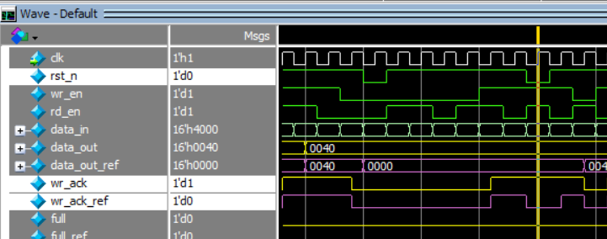

FIX:

    if (!F_if.rst_n) begin

        wr_ptr <= 0;

        F_if.wr_ack <= 0; //

    end

**/// ** Bug_2: The signal overflow is sequential so it must be reset to zero when reset is activate ** ///**



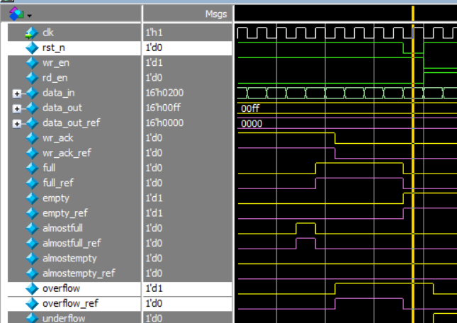

Fix:

    if (!F_if.rst_n) begin

        wr_ptr <= 0;

        F_if.wr_ack <= 0; //

        F_if.overflow <= 0; //

    end

**/// ** Bug_3: The data_out bus is sequential so it must be reset to zero when reset is activate ** ///**



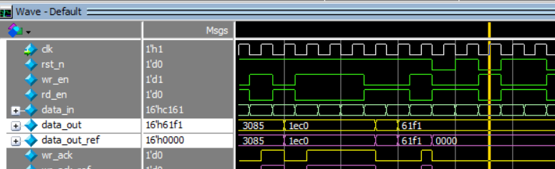

FIX:

    if (!F_if.rst_n) begin

        rd_ptr <= 0;

        F_if.underflow <= 0;// Fix

        F_if.data_out <= 0;// Fix

    end

**/// ** Bug_4: underflow must be sequential not combinational ** ///**

Bug in code:

assign underflow = (empty && rd_en)? 1 : 0;

Bug in waveform:



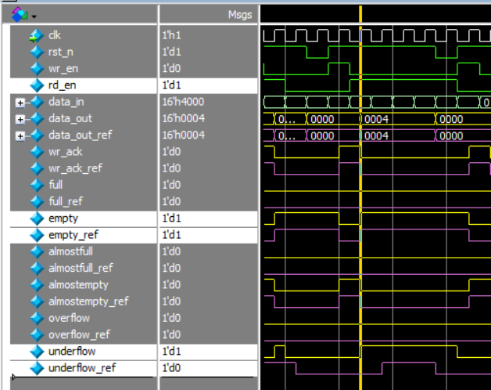

FIX:

    else if (F_if.rd_en && count != 0) begin

        F_if.data_out <= mem[rd_ptr];

        rd_ptr <= rd_ptr + 1;

        F_if.underflow <= 0; // FIX

    end

    else begin // FIX

        if (F_if.empty && F_if.rd_en)// FIX

            F_if.underflow <= 1;// FIX

        else // FIX

            F_if.underflow <= 0;// FIX

    end // FIX

// assign F_if.underflow = (F_if.empty && F_if.rd_en)? 1 : 0; //

**/// ** Bug_4 cont.: The underflow is sequential so it must be reset to zero when reset is activate ** ///**

always @(posedge F_if.clk or negedge F_if.rst_n) begin

    if (!F_if.rst_n) begin

        rd_ptr <= 0;

        F_if.underflow <= 0;// Fix

        F_if.data_out <= 0;// Fix

    end

**/// ** Bug_5: Counter is not handle the case of wr_en and rd_en both are high ** ///**

Bug in code:

always @(posedge clk or negedge rst_n) begin

    if (!rst_n) begin

        count <= 0;

    end

    else begin

        if  ( ({wr_en, rd_en} == 2'b10) && !full)

            count <= count + 1;

        else if ( ({wr_en, rd_en} == 2'b01) && !empty)

            count <= count - 1;

    end

end

Fix:

        if (({F_if.wr_en, F_if.rd_en} == 2'b11) && F_if.full) // FIX

            count <= count - 1; // FIX

        else if (({F_if.wr_en, F_if.rd_en} == 2'b11) && F_if.empty) // FIX

            count <= count + 1; // FIX

        else if ( ({F_if.wr_en, F_if.rd_en} == 2'b10) && !F_if.full)

            count <= count + 1;

        else if ( ({F_if.wr_en, F_if.rd_en} == 2'b01) && !F_if.empty)

            count <= count - 1;

**/// ** Bug_6: almostfull is high when internal signal “count” is less than FIFO_DEPTH by one** ///**



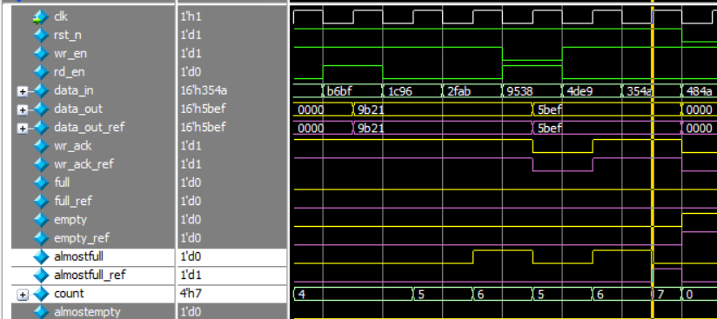

assign almostfull = (count == FIFO_DEPTH-2)? 1 : 0;

Fix:

assign F_if.almostfull = (count == FIFO_DEPTH-1)? 1 : 0; //

**/// ** Bug_7: overflow** ///**

FIFO is full => inputs( wr_en = 1, rd_en = 1) then overflow gets high and FIFO no longer full

At next clk cycle inputs( wr_en = 1, rd_en = X) write operation will succeed but overflow still high



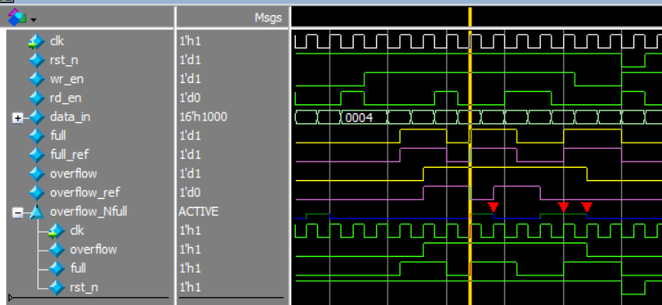

Fix:

    else if (F_if.wr_en && count < FIFO_DEPTH) begin

        mem[wr_ptr] <= F_if.data_in;

        F_if.wr_ack <= 1;

        wr_ptr <= wr_ptr + 1;

        F_if.overflow <= 0; // FIX

    end

**/// ** Bug_8: in if condition should be “&&” not “&” only to achieve 100% Condition Coverage** ///**

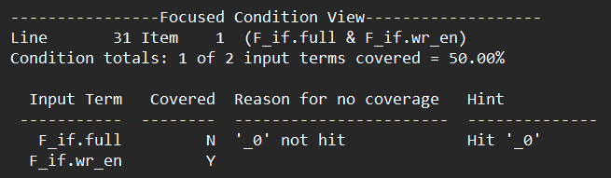

        if (F_if.full & F_if.wr_en)

            F_if.overflow <= 1;

Fix:

        if (F_if.full && F_if.wr_en)// FIX

            F_if.overflow <= 1;

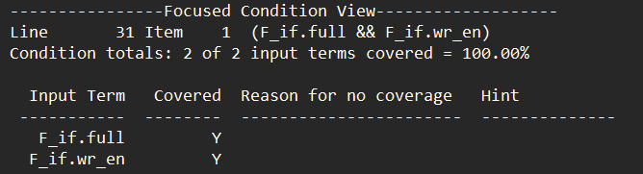

**/// ** Bug_9: when rst_n is activated then empty signal must be zero** ///**



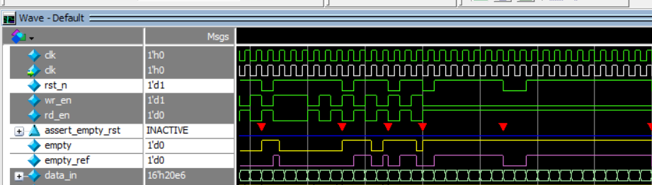

Fix:

assign F_if.empty = (count == 0 && F_if.rst_n)? 1 : 0; // FIX

|  |  |
| --- | --- |
| Bugs report summary. | |
| 1. wr_ack | reset when reset is activated |
| 1. overflow | reset when reset is activated |
| 1. underflow | Add instruction to make it sequential. |
| 1. underflow | reset when reset is activated |
| 1. data_out | reset when reset is activated |
| 1. count | Adding case when wr_en and rd_en are high |
| 1. almostfull | High when count less than FIFO_DEPTH by 1 not 2 |
| 1. overflow | Must get low when full is zero |
| 1. If statement | Should be “&&” not “&” |
| 1. empty | empty must get low when reset is activated |

Questa Snippet

/// Big Picture for assertion shows that they are activated///

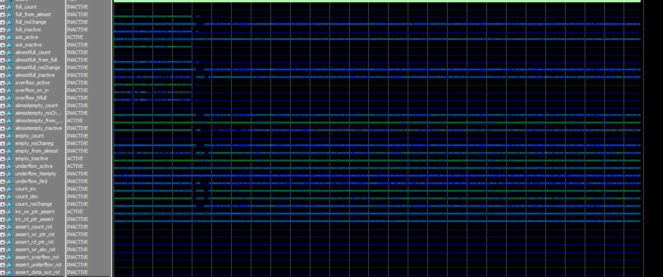

/// Big Picture for signals ///

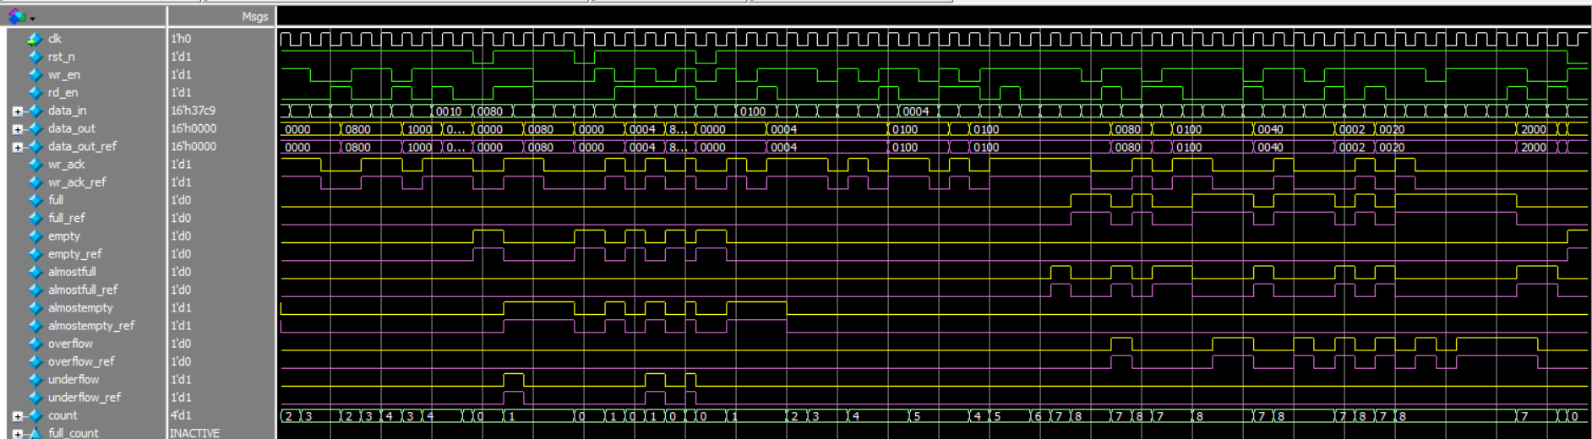

// Constraint CON_W_R_DIST ///

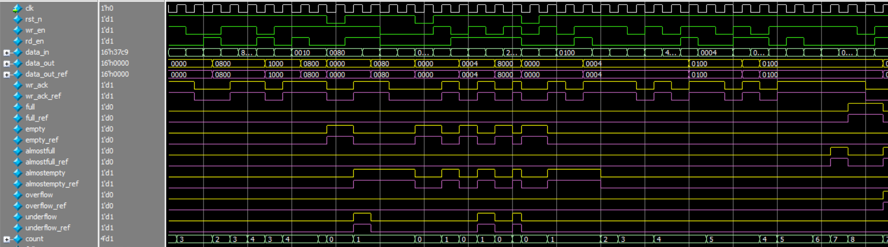

/// Constraint MY_CON_ONLEY_W ///

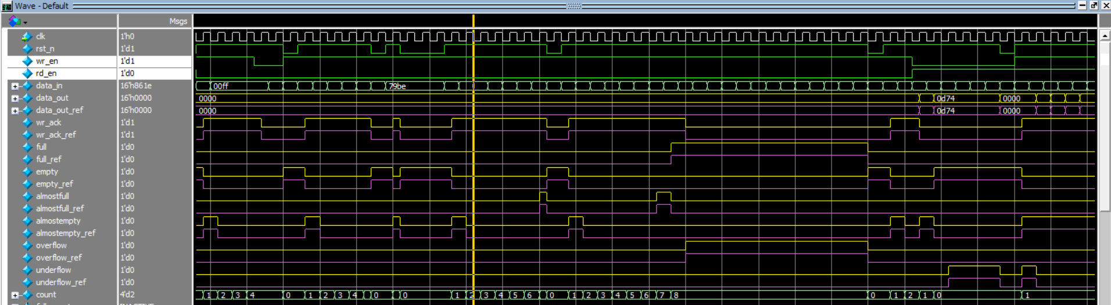

/// Constraint MY_CON_ONLEY_R ///

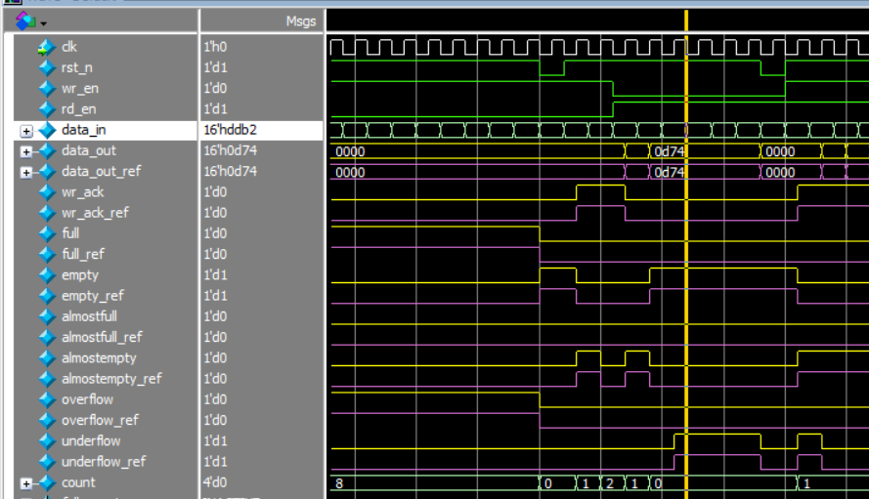

/// Constraint MY_CON_BOTH_ACTIVE ///

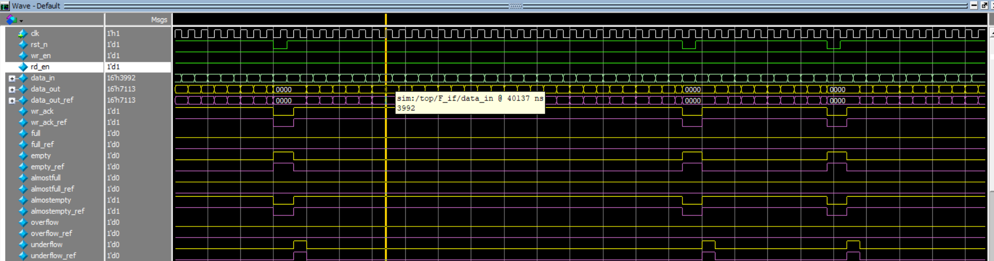

/// Constraint MY_CON_OPPSITE ///

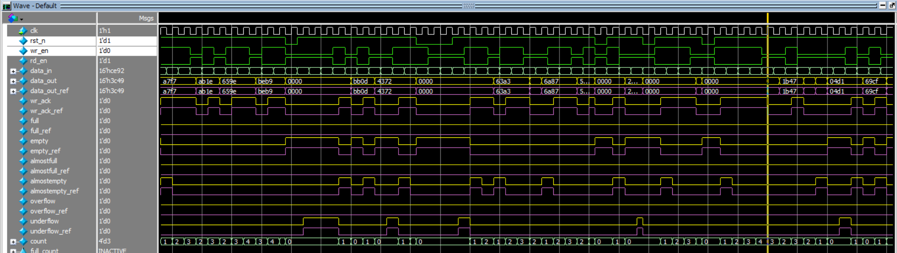

/// Constraint Toggle ///

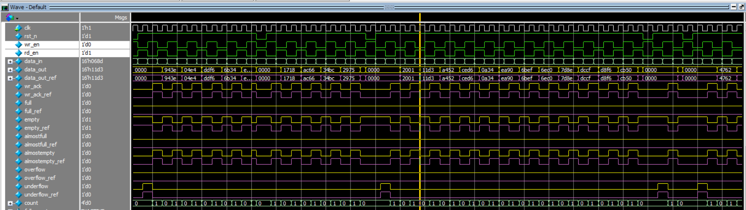

/// Constraint CON_DATA_OUT_ONE_BIT ///



/// Constraint CON_DATA_OUT_M_Z ///



/// reset activate ///

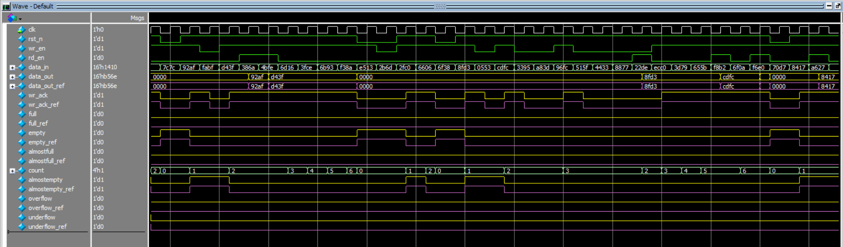

/// Write Acknowledge///

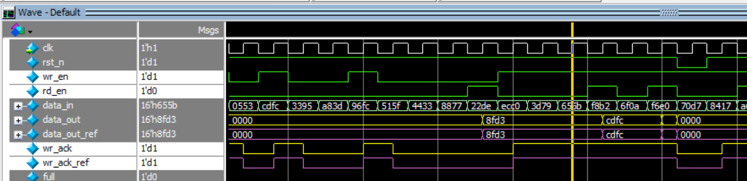

/// Write until gets full///

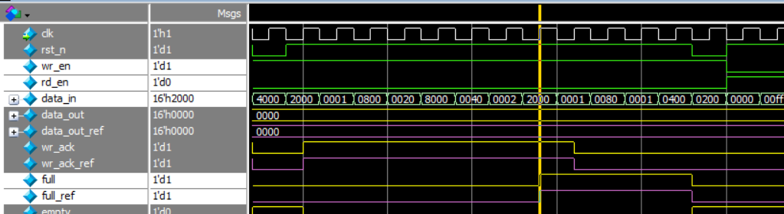

/// Read until gets empty///

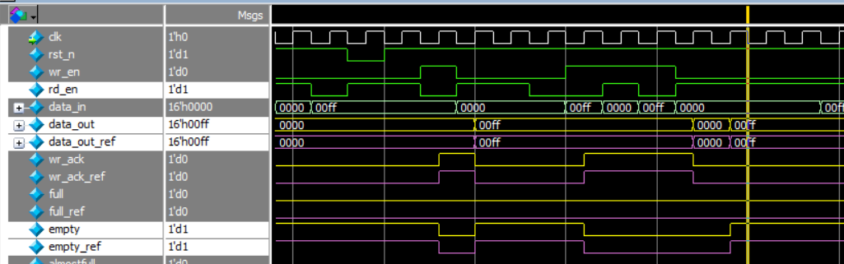

/// Overflow///

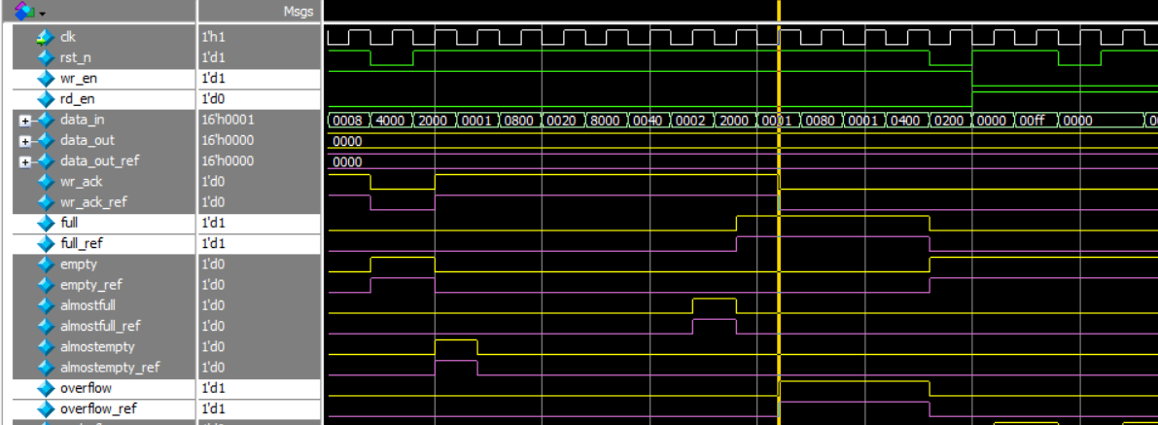

/// Underflow///

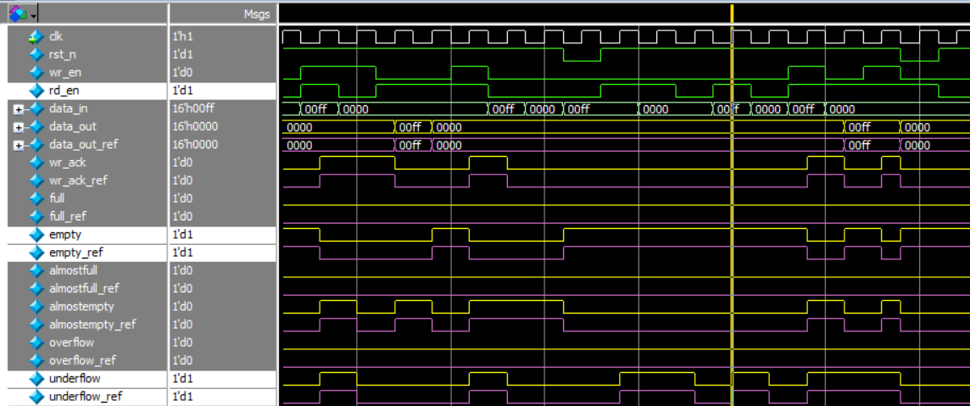

/// almost_full///

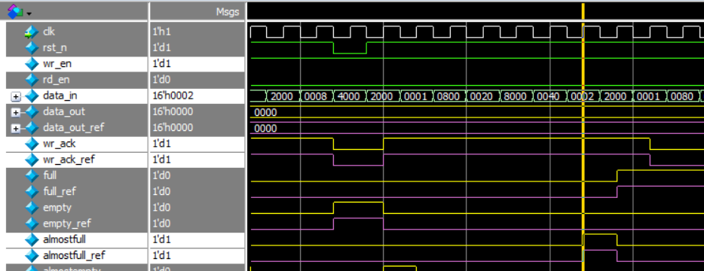

/// almost_empty///

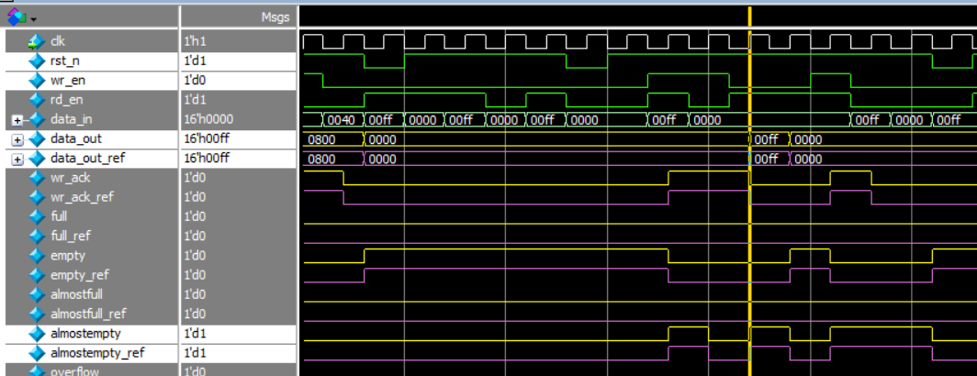

**/// Summary at the end of simulation ///**

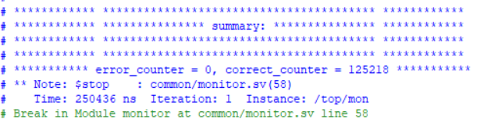

**/// Assertion ///**

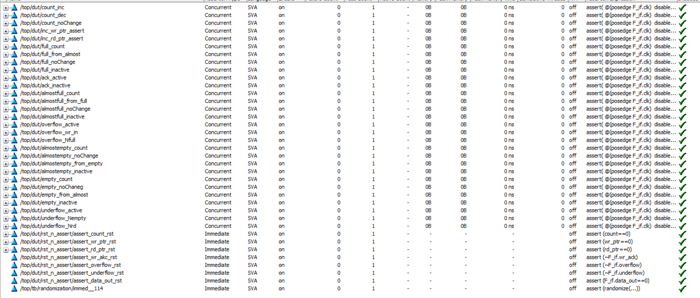

**/// Coverage directive ///**

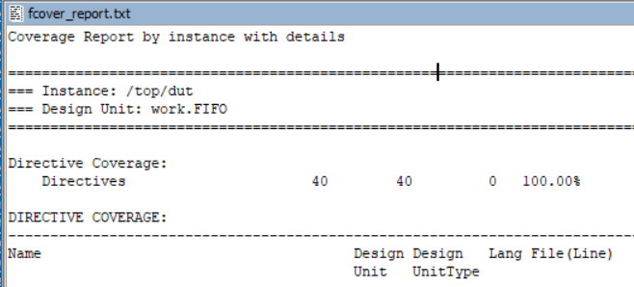

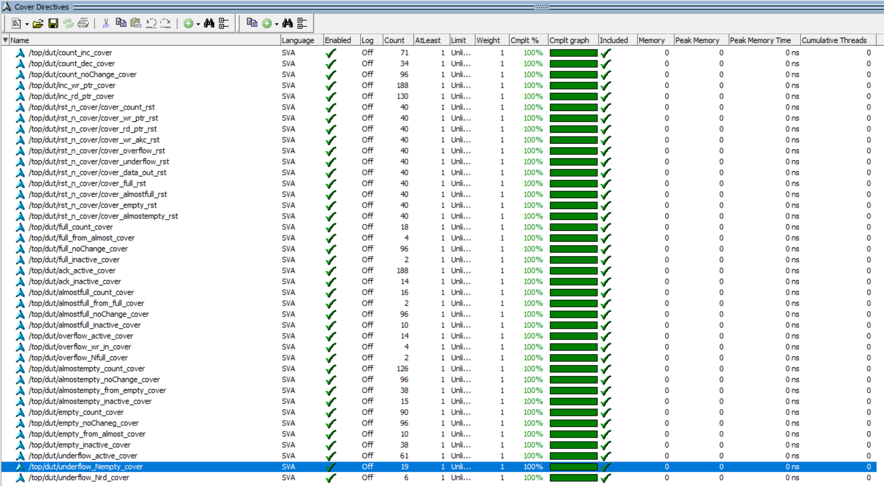

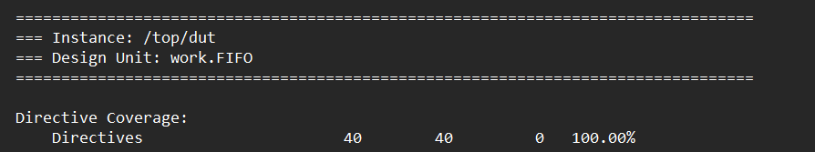

**/// Covergroup ///**

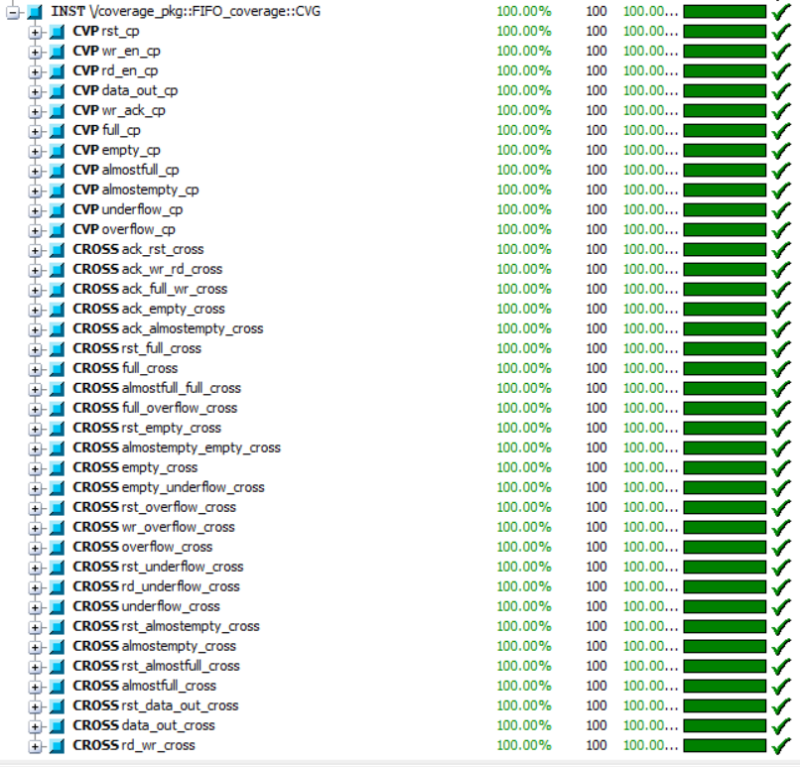

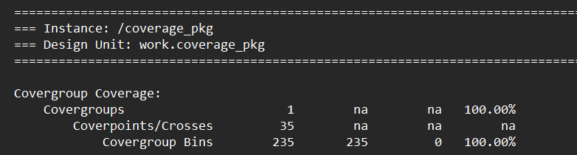

**/// Code Coverage Summary ///**

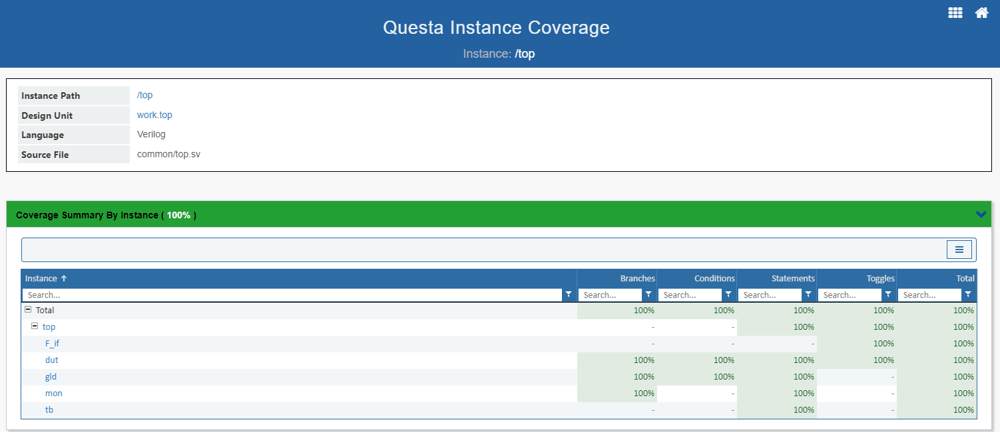

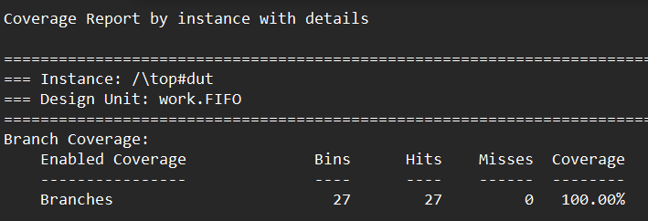

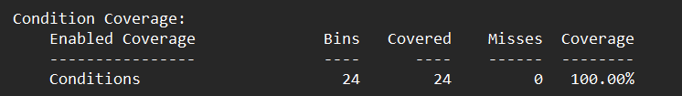

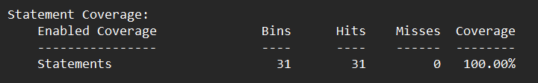

FIFO toggle for internal signal (wr_ptr, rd_ptr and count)

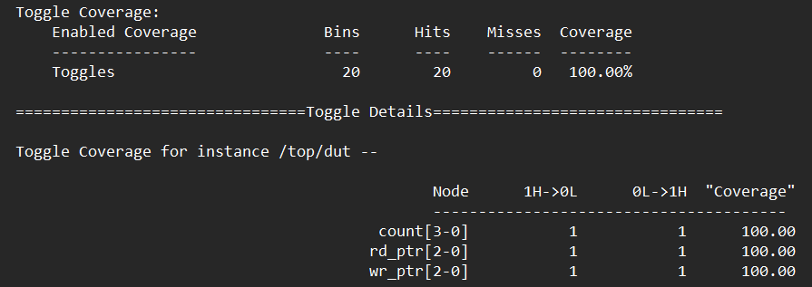

FIFO_interfase toggle for all signals (inputs and outputs)

